Chapter 13: Risk, Return, and the Security Market Line

- Determining Portfolio Weights: What are the portfolio weights for a portfolio that has 180 shares of Stock A that sell for $45 per share and 140 shares of Stock B that sell for $27 per share?

The portfolio weight of an asset is total investment in that asset divided by the total portfolio value. First, we find the portfolio value, which is:

The portfolio weight fir each stock is:

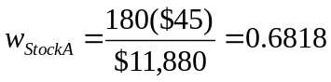

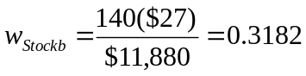

- Calculating Expected Returns and Standard Deviation: Based on the following information, calculate the expected return and standard deviation for the two stocks:

State of Probability Rate If State Occurs
Economy Of State Stock A Stock B
Recession 0.15 0.05 -0.17
Normal 0.65 0.08 0.12
Boom 0.20 0.13 0.29

The expected return of an asset is the sum of the probability of each state of the economy occurring times the rate of return if that economic state occurs. So, the expected return of each asset (i.e., Stock A and Stock B) is:

To calculate the standard deviation, we first need to calculate the variance. To find the variance, we find the squared deviations from the expected return. We then multiply each possible squared deviation by its probability, and then add all of these up. The result is the variance. So, the variance and standard deviations of each stock are:

- Calculating Portfolio Betas: You own a stock portfolio invested 25% in Stock Q, 20% in Stock R, 15% in Stock S, and 40% in Stock T. The betas for these stocks are 0.84, 1.17, 1.11, and 1.36, respectively. What is the portfolio beta?

The beta of a portfolio is the sum of the weight of each asset times the beta of each asset. So, the beta of this portfolio is:

14. Using CAPM: A stock has an expected return of 10.2%, the risk-free rate is 4.5%, and the market risk premium is 8.5%. What must the beta of this stock be?

We are given the values for the CAPM except for the beta of the stock. We need to substitute these values into the CAPM (i.e., SML) equation, and solve for the stock’s beta.

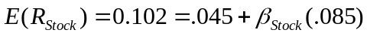

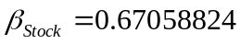

19. Reward-to-Risk Ratios: Stock Y has beta of 1.30 and an expected return of 18.5%. Stock Z has a beta of 0.70 and an expected return of 12.1%. If the risk-free rate is 8% and the market risk premium is 7.5%, are these stocks correctly priced?

There are two ways to correctly answer this question. We will work through both. First, we can use the CAPM. Substituting in the values we are given for each stock, we find:

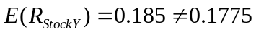

It is given in the problem that the expected return on Stock Y is 18.5%, but according to CAPM, the return on Stock Y based on its level of risk, the expected return should be 17.75%. This means Stock Y’s expected return is too high given its level of risk. Therefore, Stock Y plots above the SML and is undervalued. In other words, its price must increase to reduce the expected return from 18.5% to 17.75%.

For Stock Z, we find:

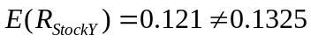

The expected return given for Stock Z is 12.1%, but according to CAPM the expected return should be 13.25%. Stock Z plots below the SML and is overvalued. In other words, its price must decrease in order to increase the expected return from 12.1% to 13.25%.

We can also answer this question using the reward-to-risk ratio. All assets must have the same reward-to-risk ratio, i.e., every asset must have the same ratio of the asset’s risk premium to its beta. That is, the reward-to-risk ratio is the risk premium of the asset divided by its beta. This is also known as the Treynor ratio or Treynor index. We are given the expected return and beta for each stock. We are also given the risk-free rate, so we can calculate each stock’s risk premium (i.e., expected return minus the risk-free rate). Calculating the reward-to-risk ratio for Stock Y, we find:

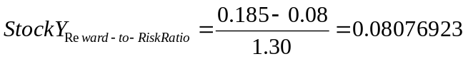

The reward-to-risk ratio for Stock Z can similarly be calculated as:

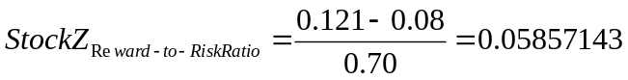

We are also given the market risk premium of 7.5%. Therefore, the market’s reward-to-risk ratio is:

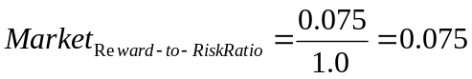

Stock Y’s reward-to-risk ratio is higher than that of the market, which means the stock plots above the SML, and is therefore undervalued. Stock Y’s price must increase until its reward-to-risk ratio is equal to that of the market’s reward-to-risk ratio.

The reward-to-risk ratio for Stock Z is too low compared to that of the market, which means the stock plots below the SML, and the stock is overvalued. Stock Z’s price must decrease until its reward-to-risk ratio is equal to that of the market’s reward-to-risk ratio.

22. CAPM: Using the CAPM, show that the ratio of the risk premiums on two assets is equal to the ratio of their betas.

From the problem above, we know that the reward-to-risk ratios for all assets must be equal. This can be expressed as:

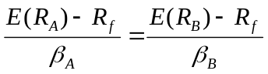

The numerator of each equation is the risk premium of the asset, so:

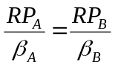

We can rearrange this equation to get:

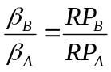

If the reward-to-risk ratios are the same for both assets, the ratio of the betas of the two assets is equal to the ratio of the risk premiums of the two assets.

26. Systematic versus Unsystematic Risk: Consider the following information about Stocks I and II:

State of Probability Rate If State Occurs
Economy Of State Stock I Stock II
Recession 0.25 0.11 -0.40
Normal 0.50 0.29 0.10
Irrational Exuberance 0.25 0.13 0.56

The market risk premium is 8%, and the risk-free rate is 4%. Which stock has the most systematic risk? Which one has the most unsystematic risk? Which stock is “riskier”? Explain.

The amount of systematic risk is measured by the beta of an asset. Since we know the market risk premium (8%) and the risk-free rate (4%), if we know the expected return of the asset we can use the CAPM to solve for the beta of the asset. The expected return of Stock I is:

Using the CAPM to find the beta of Stock I, we find:
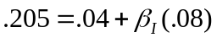
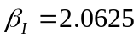

The total risk of the asset is measured by its standard deviation, so we need to calculate the standard deviation of Stock I. We begin with calculating the variance:

We can use the same procedure for Stock II to find the expected return:

Using the CAPM to find the beta of Stock II, we find:

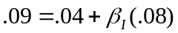
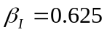

And again, the total risk of the asset is measured by its standard deviation, so we need to calculate the standard deviation of Stock II. We begin with calculating the variance:

Although Stock II has more total risk, it has less systematic risk since its beta is much smaller than Stock I’s. Thus, Stock I has more systematic risk and Stock II has more unsystematic risk and total risk. Since unsystematic risk can be diversified away, Stock I is actually the “riskier” stock despite the lack of volatility in its returns. Stock I will have a higher risk premium and a greater expected return!

